**Ultimate 64 Keyboard Extension Rev. 0**

**Module Description**

This is a keyboard extension for the Ultimate 64. It was designed in collaboration with @edu_arana.

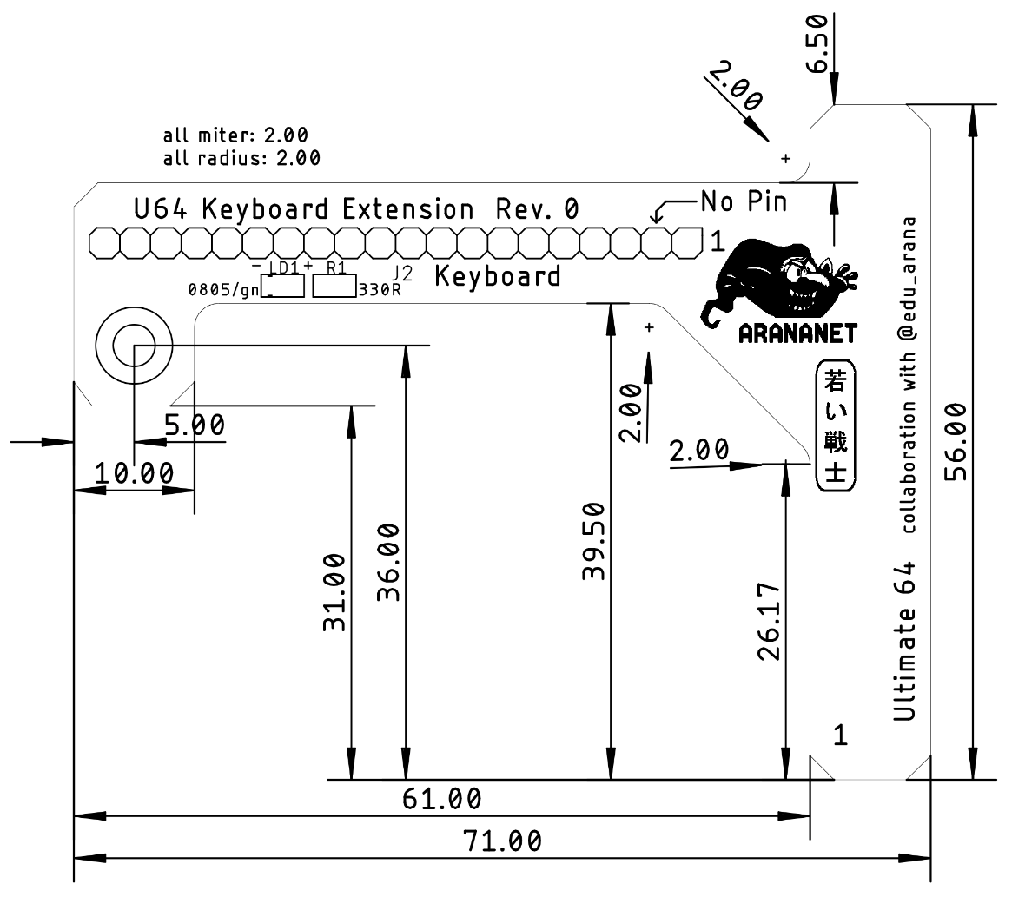

Figure 1: Dimensions

When using the 3D printed keyboard mounting bracket (<https://www.thingiverse.com/thing:3220123>), the access to the keyboard connector is blocked. Also, some keyboard cables are too short, so it does not reach the position of the connector or it is installed with a not acceptable tension. The Ultimate 64 Keyboard Extension fixes this problem.

The PCB offers an optional power LED (SMD 0805).

# Connectors

## J1 - Keyboard connector to Ultimate 64

Receptacle (1x20p, pitch 2.54mm) – Harwin M20-7862042

| Pin | Signal | Pin | Signal |
| --- | --- | --- | --- |
| **1** | GND | **11** | ROW1 (PB1) |
| **2** | No pin | **12** | ROW0 (PB0) |
| **3** |  | **13** | COL0 (PA0) |
| **4** | +5V | **14** | COL6 (PA6) |
| **5** | ROW3 (PB3) | **15** | COL5 (PA5) |
| **6** | ROW6 (PB6) | **16** | COL4 (PA4) |
| **7** | ROW5 (PB5) | **17** | COL3 (PA3) |
| **8** | ROW4 (PB4) | **18** | COL2 (PA2) |
| **9** | ROW7 (PB7) | **19** | COL1 (PA1) |
| **10** | ROW2 (PB2) | **20** | COL7 (PA7) |

## J2 – Pin Header to Keyboard

Standard 1x20p, pitch 2.54. Pin 2 has to be removed to fit the C64 keyboard connector. The pin out is identical to J1.

# Mounting

The distance between this keyboard extension and the bottom of the case depends on the height of the receptacle. With a 8mm high receptacle, it is approximately 16mm. The project includes 3D printed a stand-off of this height.

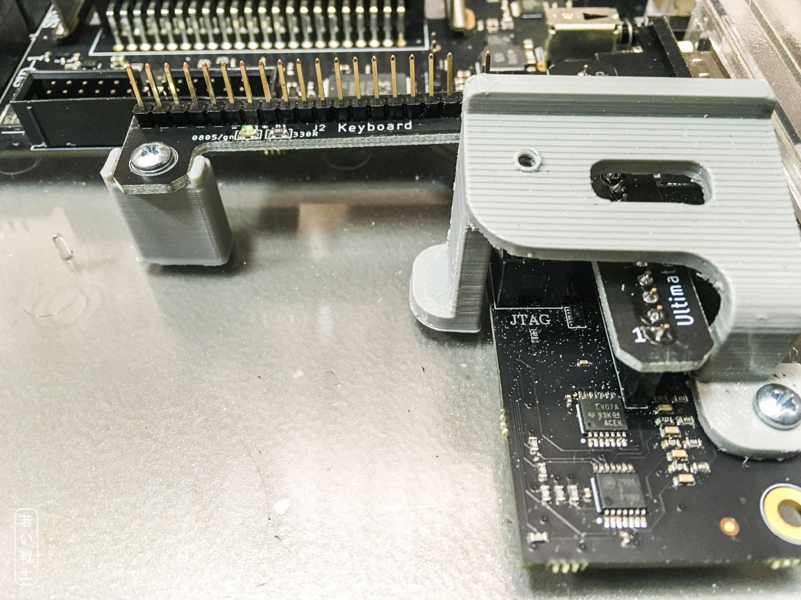

Figure 2: Mounting of the keyboard extension with stand-off and keyboard bracket

The recommended screw for the stand-off is a C2.9x9.5 DIN 7981.

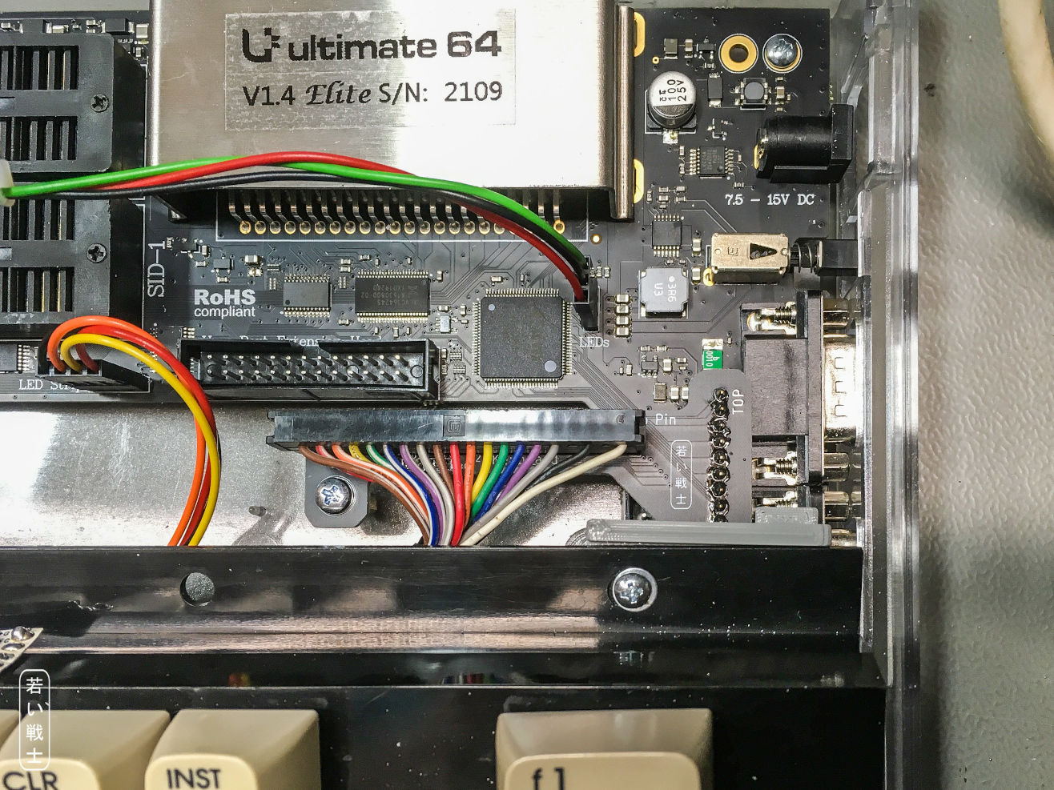

Figure 3: Complete assembly with keyboard installed